Project Report
Customer Purchase Behaviour Analysis
Problem Statement:
A leading retail company wants to better understand its customers’ shopping behaviour in order to improve sales, customer satisfaction, and long-term loyalty. The management team has noticed changes in purchasing patterns across demographics, product categories, and sales channels (online vs. offline). They are particularly interested in uncovering which factors, such as discounts, reviews, seasons, or payment preferences, drive consumer decisions and repeat purchases.
You are tasked with analysing the company’s consumer behaviour dataset to answer the following overarching business question:
"How can the company leverage consumer shopping data to identify trends, improve customer engagement, and optimize marketing and product strategies?"
Project Overview:
This project analyzes customer purchasing behaviour using transactional data of approximately 3,900 records. The objective is to identify spending patterns, understand customer segments, and evaluate product preferences to support data-driven business decisions.
Dataset Information:
- Total Records: 3,900
- Total Features: 18
Key Attributes:
- Customer Details: Age, Gender, Location, Subscription Status
- Purchase Information: Product Category, Purchase Amount, Season, Color
- Behavioral Data: Discount Usage, Purchase Frequency, Review Rating, Shipping Type
Note: Missing values were present in the Review Rating column.

Data Preprocessing (Python):
The dataset was cleaned and prepared using Python
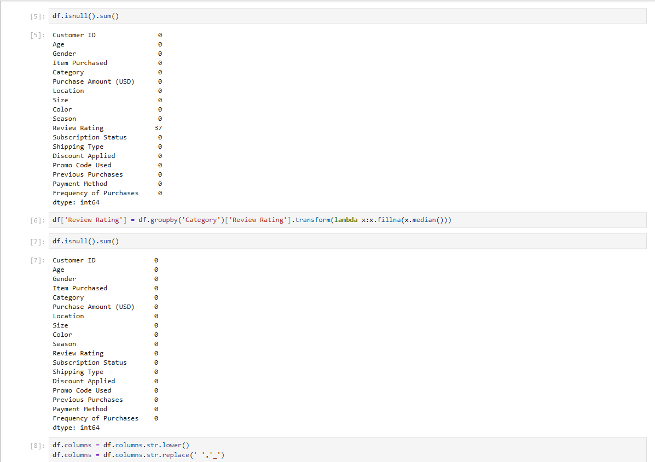
- Handled missing values using median imputation

- Standardized column names for better readability
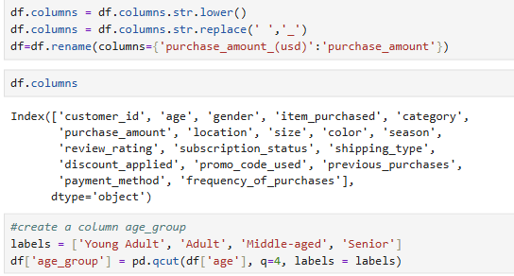

- Created new features:
Age Groups
Purchase Frequency (days)
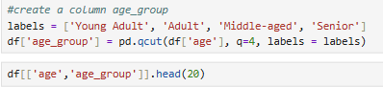

- Removed redundant columns
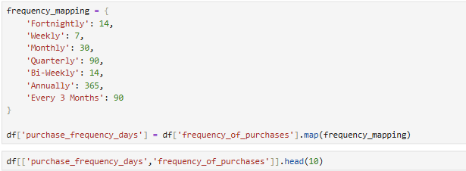
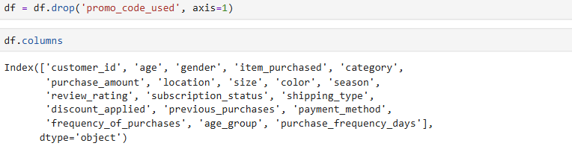
- Stored cleaned data into PostgreSQL database
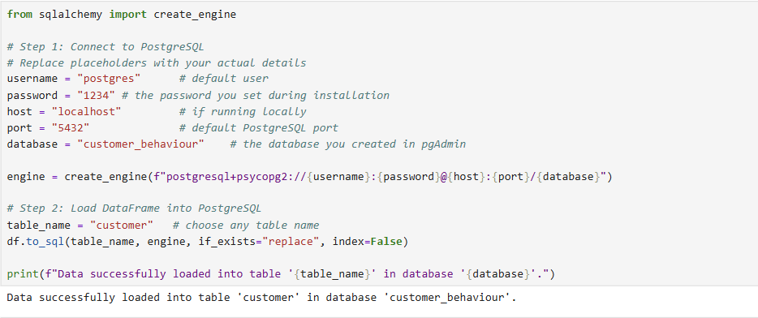

SQL Analysis:
The dataset was analyzed using SQL to extract meaningful business insights and uncover patterns in customer behavior.
- Revenue Distribution: Analysis showed differences in total revenue contribution across genders, helping identify key customer segments driving sales.
- Customer Spending Behavior: Certain customers continued to spend above average even when discounts were applied, indicating strong purchase intent.
- Product Performance: Some products consistently received higher average ratings, highlighting customer preferences and product quality perception.
- Shipping Impact: Customers choosing express shipping showed slightly higher average spending compared to standard shipping users.
- Subscription Insights: While subscription status did not significantly impact average spending, it played a crucial role in customer retention and total revenue generation.
- Discount Dependency: A few products were highly dependent on discounts, suggesting price sensitivity in specific categories.
- Customer Segmentation: Customers were categorized into New, Returning, and Loyal segments, with loyal customers contributing the largest share of purchases.
- Category-Level Trends: Certain product categories showed higher purchase frequency, helping identify top-performing segments.
- Repeat Purchase Behaviour: Customers with frequent purchases were more likely to engage consistently, though not always subscribed.
- Demographic Insights: Revenue contribution varied across age groups, helping identify high-value target audiences.
Power Bi Dashboard:
An interactive dashboard was created to visualize insights:
- Total Customers
- Average Purchase Value
- Category-wise Sales
- Customer Segmentation
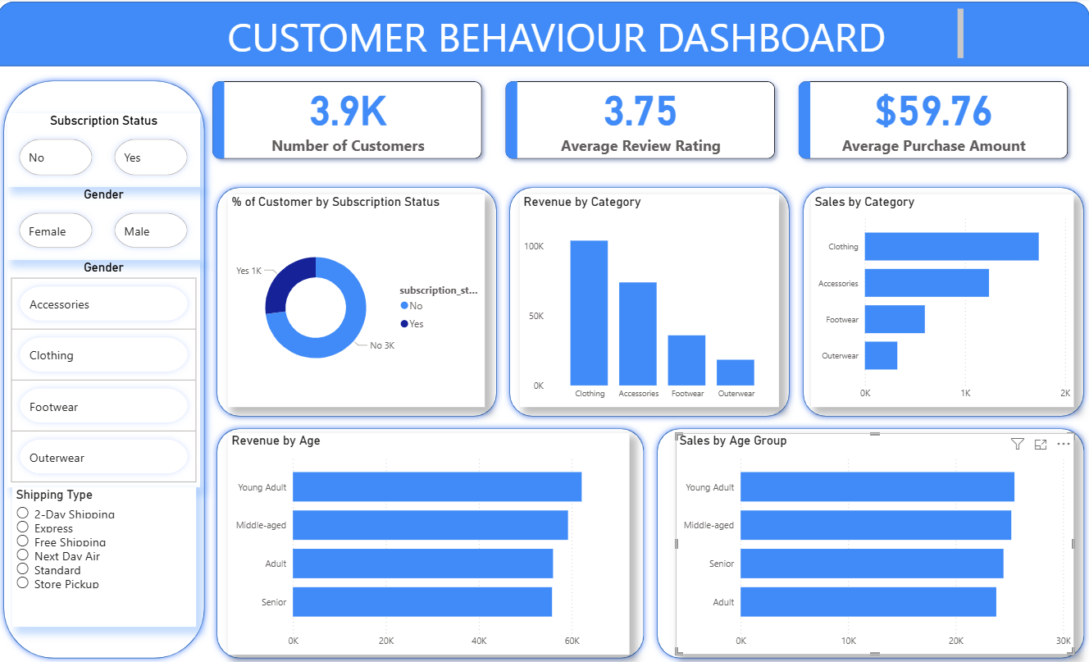
Business Recommendations:
- Boost Subscriptions – Promote exclusive benefits for subscribers.
- Customer Loyalty Programs – Reward repeat buyers to move them into the “Loyal” segment.
- Review Discount Policy – Balance sales boosts with margin control.
- Product Positioning – Highlight top-rated and best-selling products in campaigns.
- Targeted Marketing – Focus efforts on high-revenue age groups and express-shipping users.
Tools & Technologies Used:
- Python (Pandas, NumPy)
- SQL (PostgreSQL)
- Power BI
- Excel
Conclusion
This project demonstrates how data analytics can be used to extract meaningful insights from customer behavior and support strategic decision-making in business.

